

NATIONAL UNIVERSITY OF SCIENCE AND TECHNOLOGY
SCHOOL OF INTERDISCIPLINARY ENGINEERING AND SCIENCES

ML Assignment (CSE -845)
Model Comparison using Hypothesis Testing

Name: Aliya Aftab
Roll No: 538557
Instructor: Dr Tariq Saeed
Date: 8 October 2025

Task: Build a basic machine learning model using the dataset provided in class. Create and test three different hypotheses/models.
Data Understanding and Preprocessing
Firstly, I loaded the dataset, explored it to identify target variable and issues.
Started from making necessary imports:
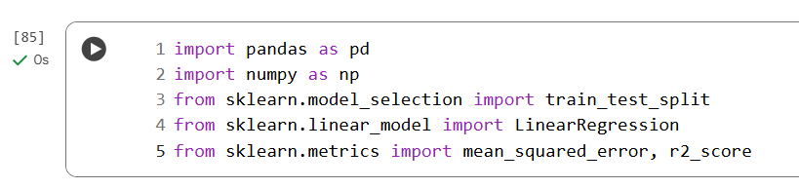
Loaded the dataset and identified “Time Taken” as the target column.

checked dataset shape and explored columns.
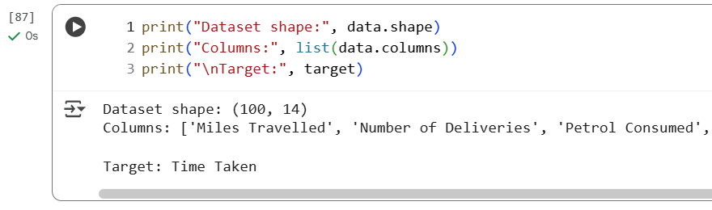
Checked duplicate rows and null values. There were no duplicates found.
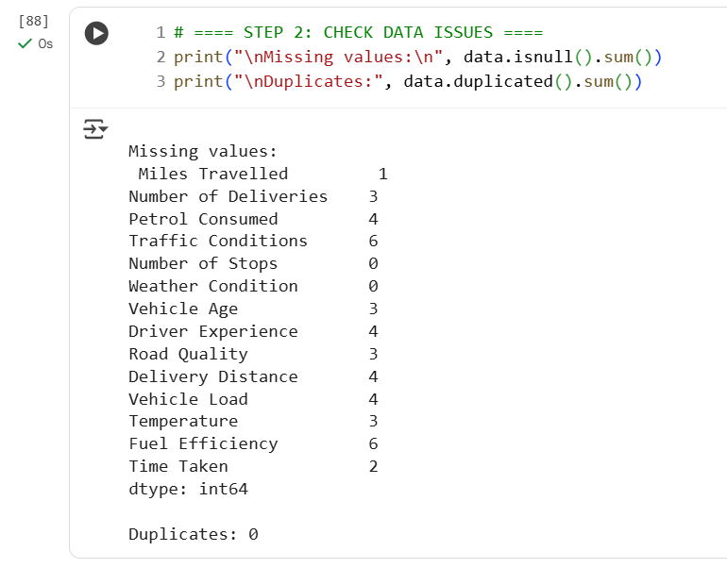
I handled null values by replacing them with median value of the column.
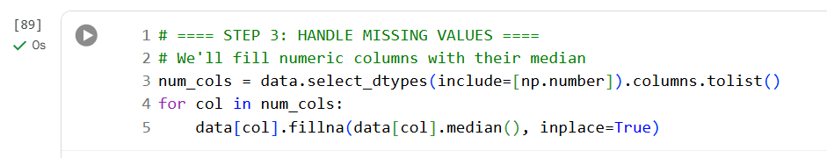
Then, I verified there were no null values left.
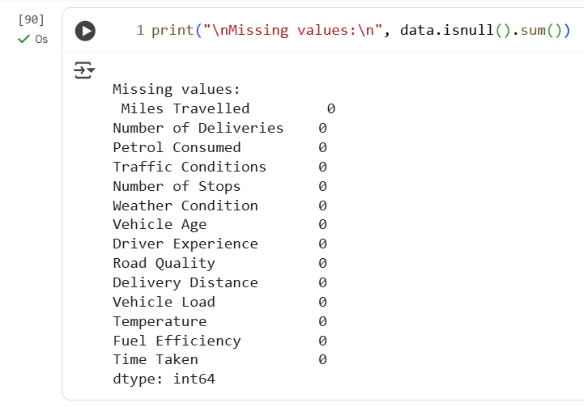
I analyzed that only weather condition column contained categorical values, so I check its unique values for encoding.
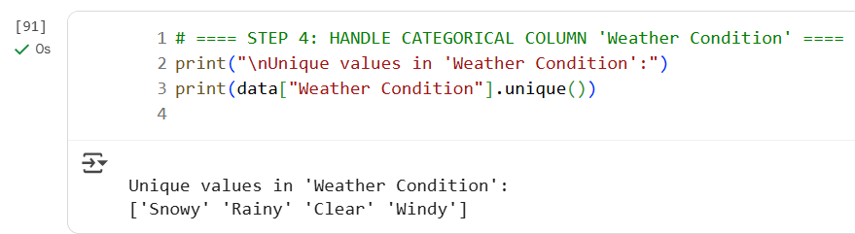
I converted weather condition into a numerical column by categorical encoding.
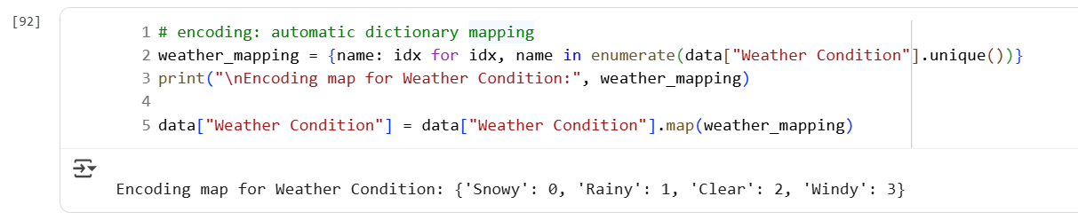
Data Splitting
Split the data into features and target.

Using train_test_split from sklearn, I split the data into train and test set with 80 20 ratio resp.
Training and Evaluation
Defined a function to train and evaluate the model, used RMSE and R2 as evaluation metrics.
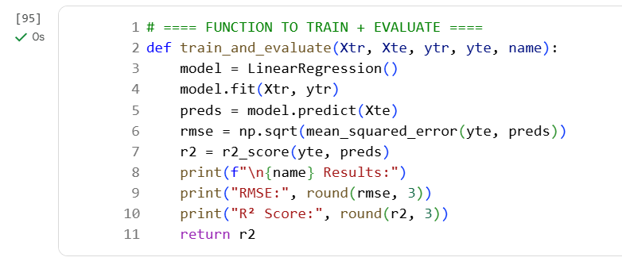
Hypothesis 1
Training the model using all variables.
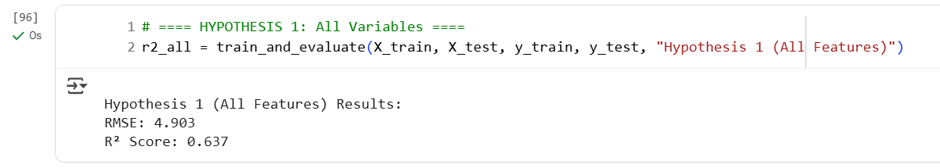
R2 – 0.637. R2 ranges from 0 – 1 while 1 is a perfect R2 score. So we want to achieve highest.
Hypothesis 2
Training the model using only the variables correlated with the target variable.
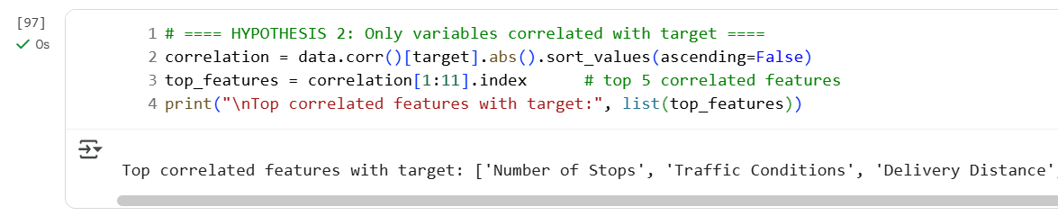
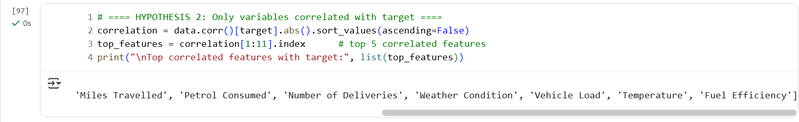
I used 10 most correlated columns shown above.
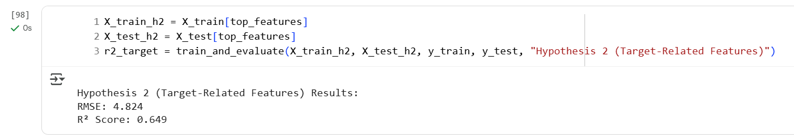
R2 is 0.649. Which is better than Hypothesis 1.
Hypothesis 3
Training the model after dropping variables that are highly correlated with each other. 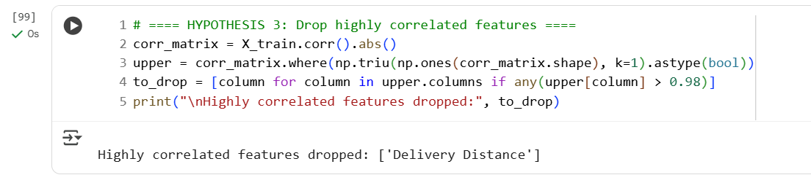
I kept correlation threshold as 0.98 so that I drop only the highly correlated columns. As a result, I dropped ‘Delivery Distance’.
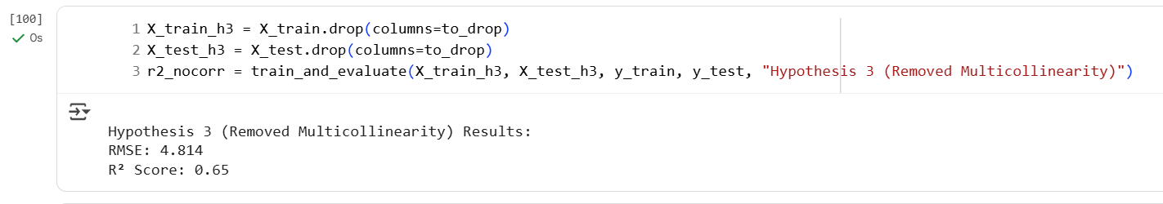
R2 is 0.65 which is even higher than Hypothesis2. So Hypothesis 3 gives the best results.
Comparison
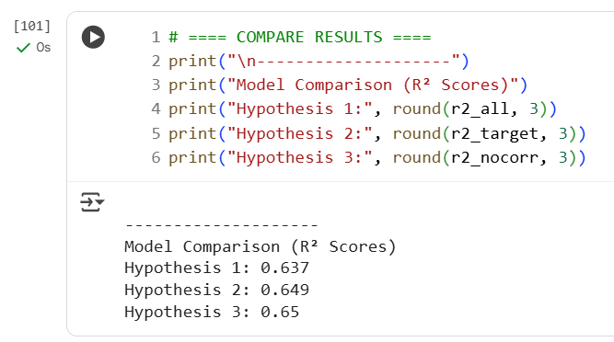
Since R2 is highest for Hypothesis 3. So, Hypothesis 3 give best model performance.
THE END

